Exercise 1:
Open Android Studio application, select “New Project” tab, and double click on “No Activity” template. Name your project as “MyLab1”, and click on “Finish” button. Expand the “app” folder, and click on “java” folder, then select the first package “com.example.myLab1” and then click on the wright button of the mouse and select “New” and then select “Java Class” (see below)

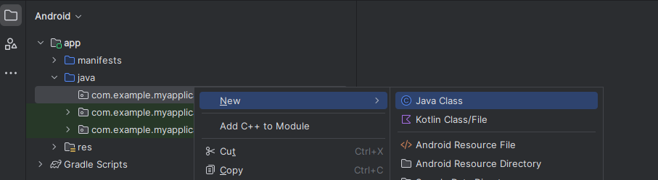

Now, type your java class name as “myLab1” and press enter. The java class will be created without main method. Add the following code

public static void main(String[] args) {
}

Add the following java statement inside the main method

System.out.println("Hello World!");

To run this program, select the “myLab1.java” under the package, and click on the right button of the mouse, and select the option “Run “myLab1.main() with Coverage” option (see below)

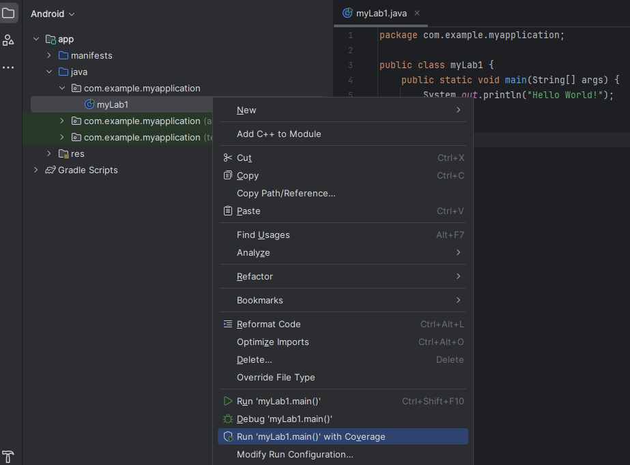
If there are no java syntax errors within your codes, then your results will show at the bottom of Android Studio (see below)
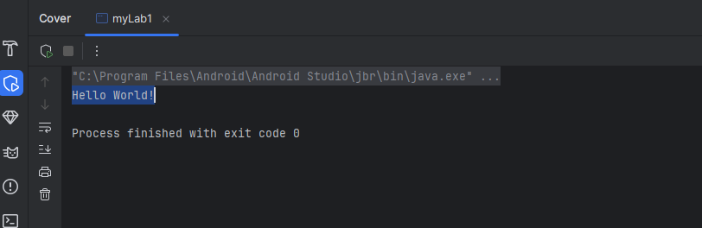

Exercise 2:
Follow the same steps as above to create java program which read two integer numbers from the Terminal window by using the Scanner java class (see the code below which is for reading only one integer value)

Scanner in = new Scanner(System.in);
System.out.print("Enter Integer:");
int j = Integer.parseInt(in.nextLine());

and then print the total of both numbers (Hint use try{} and catch{} with your codes to capture any errors)

Exercise 3:
Write Java application program that reads from the Terminal window any positive decimal number of English moneys as input value and find and print out how many £50 notes, £20 notes, £10 notes, £5 notes, and £ Coins. (Hint use the if statement, divide (/) operator and then modulo operator (%) to determine the number of notes and coins).

Exercise 4:
Write two Java methods. One to convert a temperature in Celsius into fahrenhait (F = 9 / 5 * C + 32). Other to convert a temperature in fahrenhait into celsius (C = 5 / 9 * ( F - 32 ))
Write Java code to print two temperature conversion tables, one for each convertions. (Hint: use for statement starting from 0.0 and increament by 100.0)

Exercise 5:

Inheritance in Java allows you to reuse code from an existing class into another class, you can derive new class from an existing class by using extends

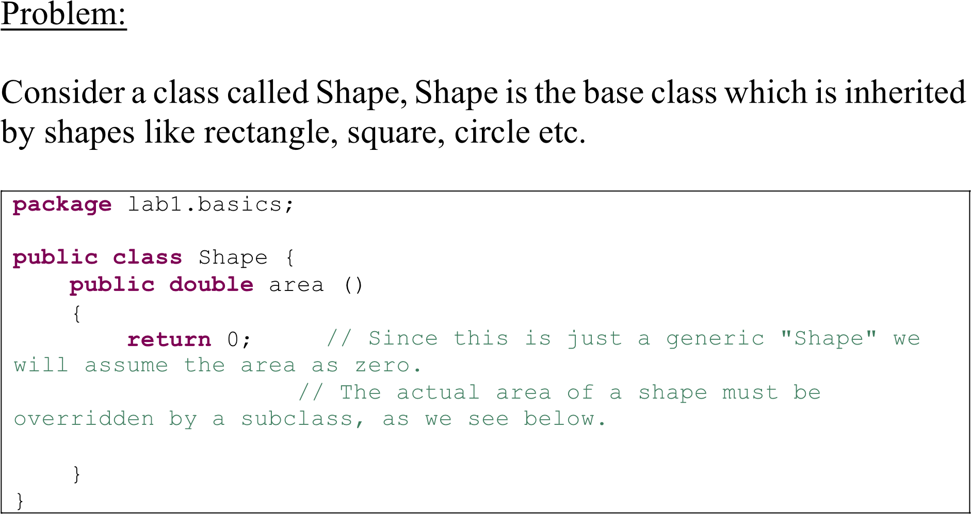

Write Circle class using the Shape class, where the area of the Circle class is

Circle Area = R² * Pi where R is the radius, and the Pi = Math.PI

Test your Circle class with radius = 5.

